Salesforce Administrator Self-Learning & Super Badges

#### SALESFORCE ADMINISTRATOR - SELF LEARNING

Sub heading:- Service Cloud Basics

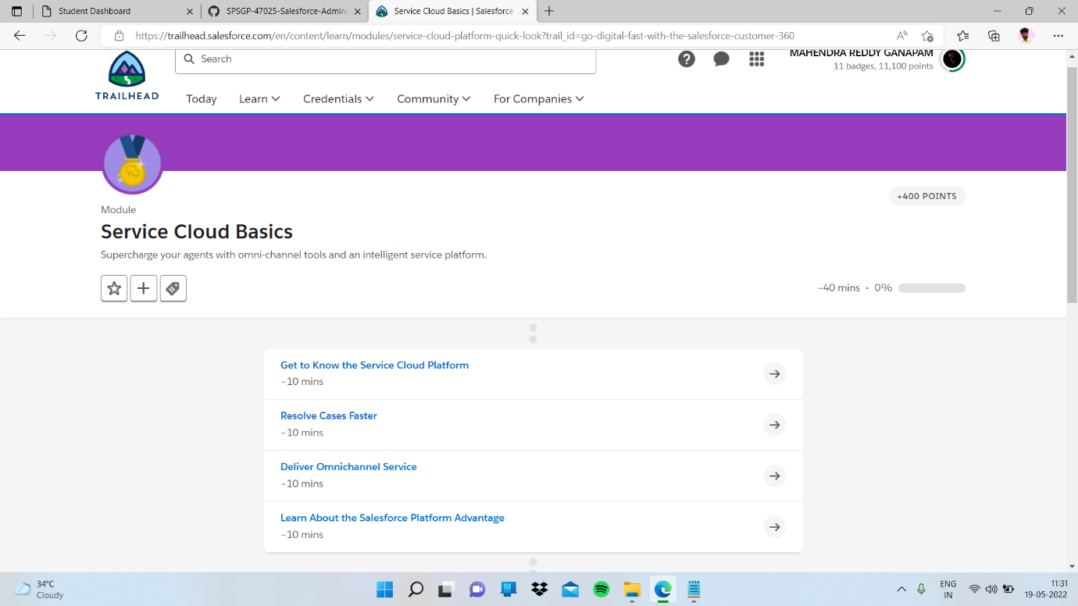

Sub topic:- Get to Know the Service Cloud Platform

In this I completed quiz

